**AWS PROJECT**

**Objective:**

**Deploy and host a highly valuable word press application using EC2 instance with Mysql database connection.**

**Procedure:**

**Step 1:**

EC2 Dashboard page in AWS(amazon web services),in this page it shows about all the status of the running items.

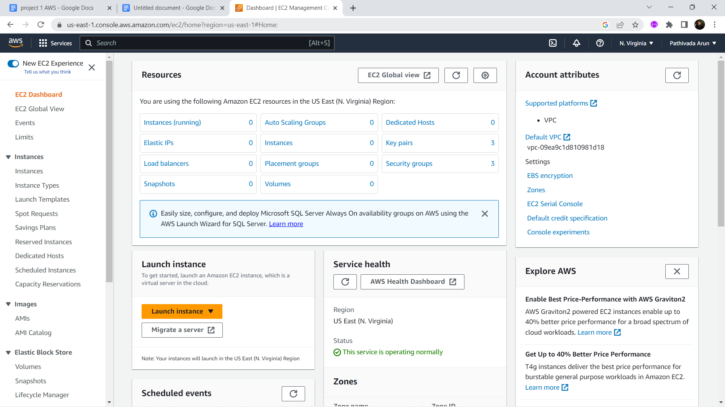

**Step 2: Launch instance page**

Open the launch instance page from the EC2 console.

Give a name to the instance as instance 1

Select an Amazon machine image(AMI) to run our tasks.

Here i selected ubuntu as my AMI.

There are multiple number of AMI are available as per our need and interest we need to select one of them from free tier eligible category.

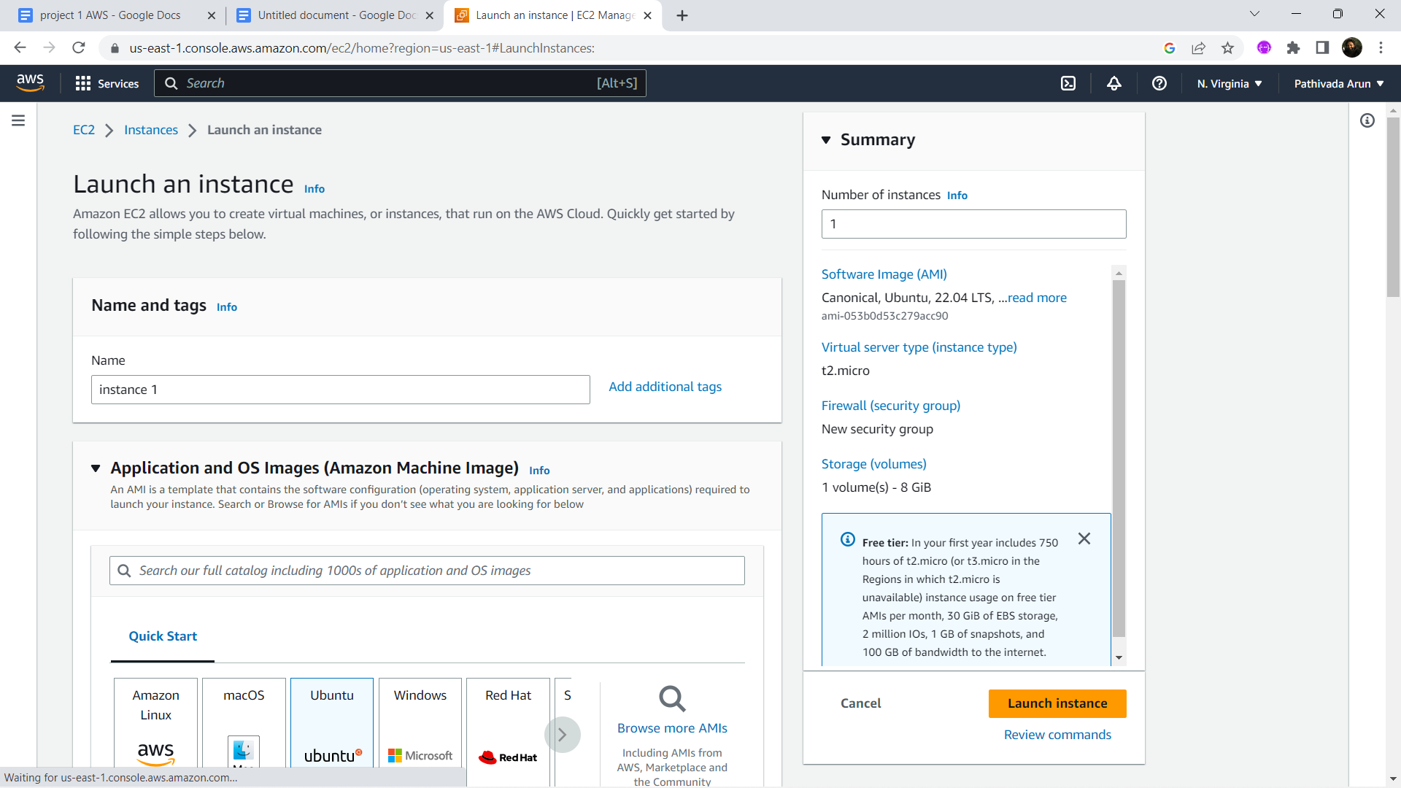

**Step 3: Instance type and key-pairs**

Select a instance type which supports a free tier eligible.

Instance type is hardware capacity for our virtual machine.

In this case i selected a t2.micro with 1 cpu and 1 GB memory.

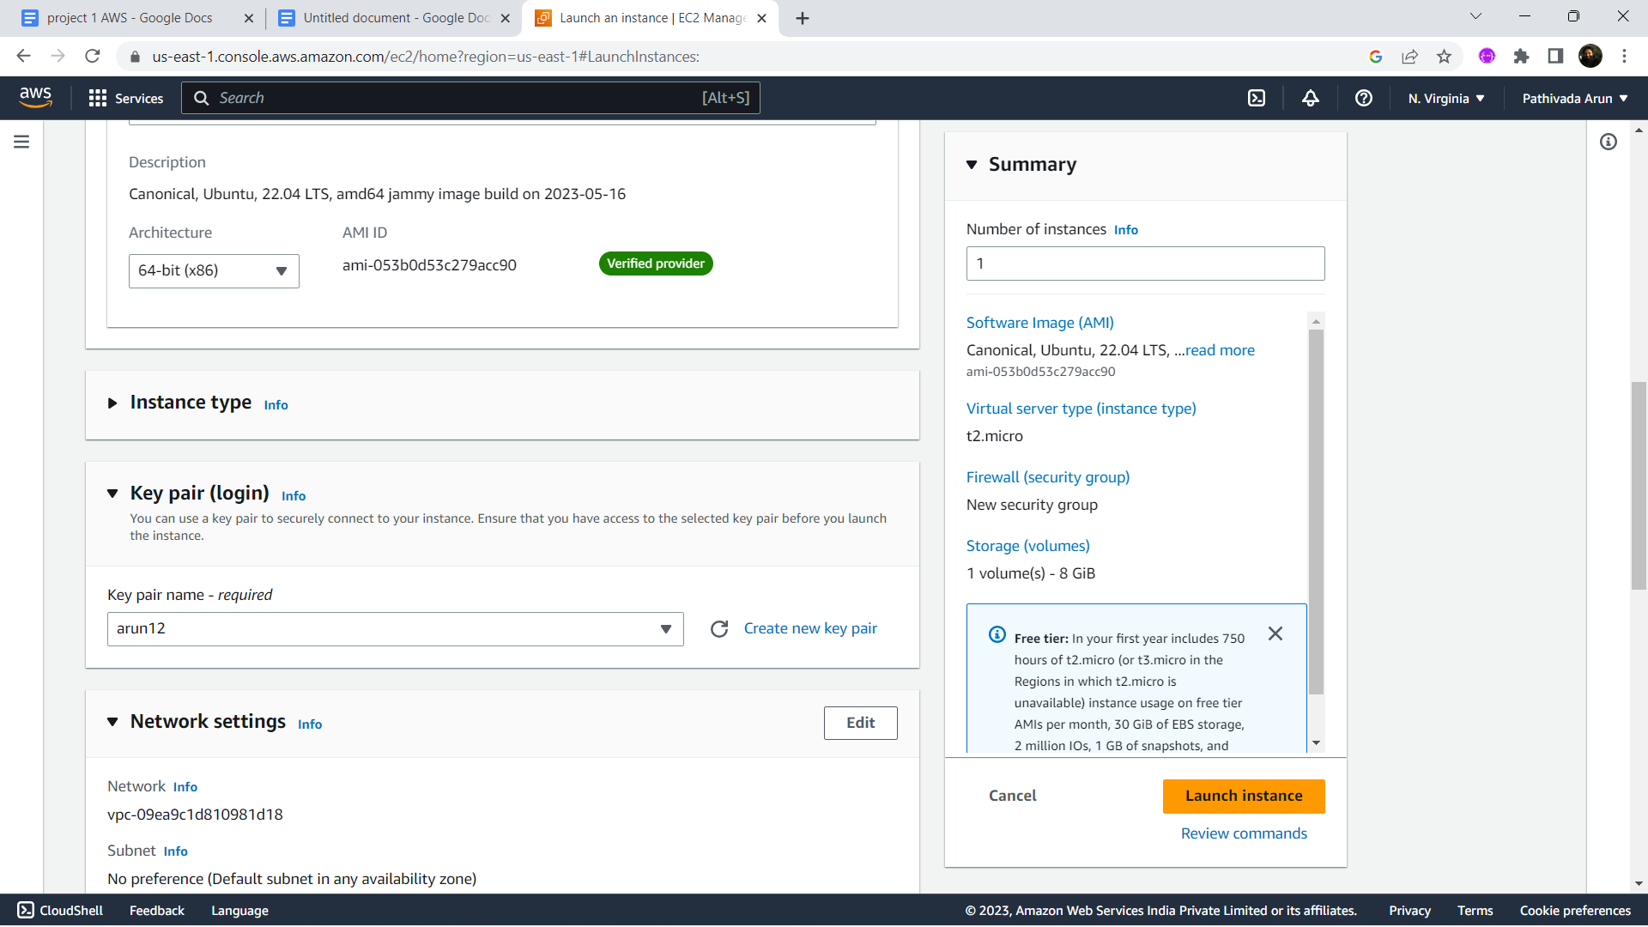

**Step 4:Security groups**

Create a security group to provide security for the instance.

Allow the SSH protocol to recieve requests from all systems around the network.

Allow HTTPS and HTTP request to connect the system through ip address.

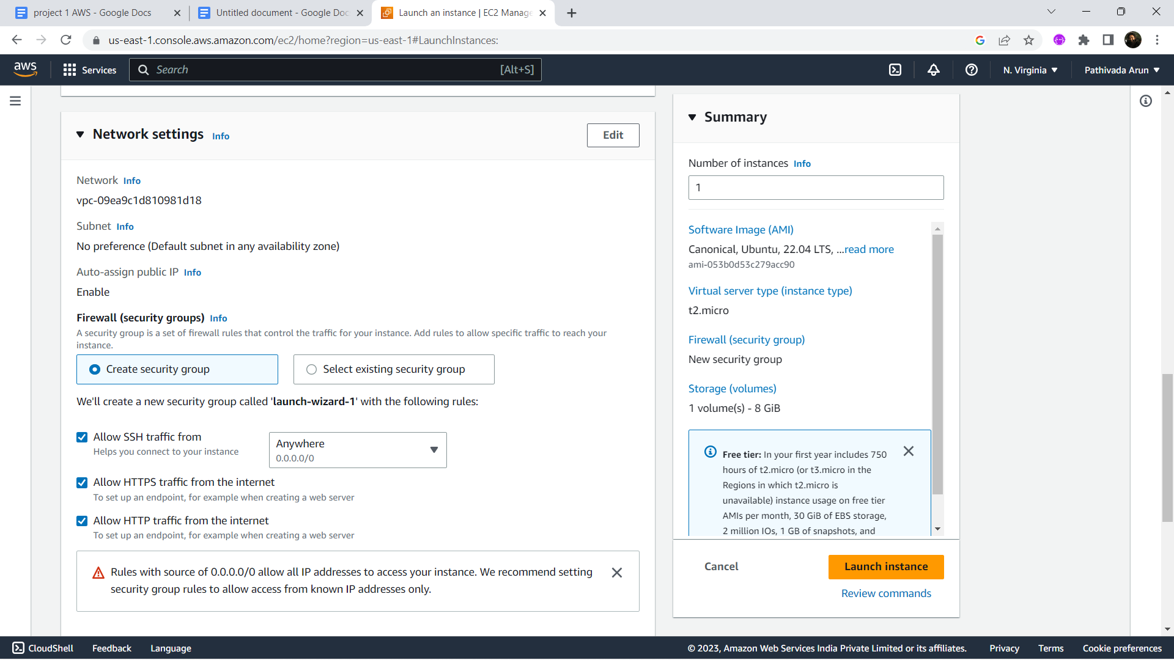

**Step 5:Configure storage**

Select the storage size as per our need.

In this case it is 8 gb.

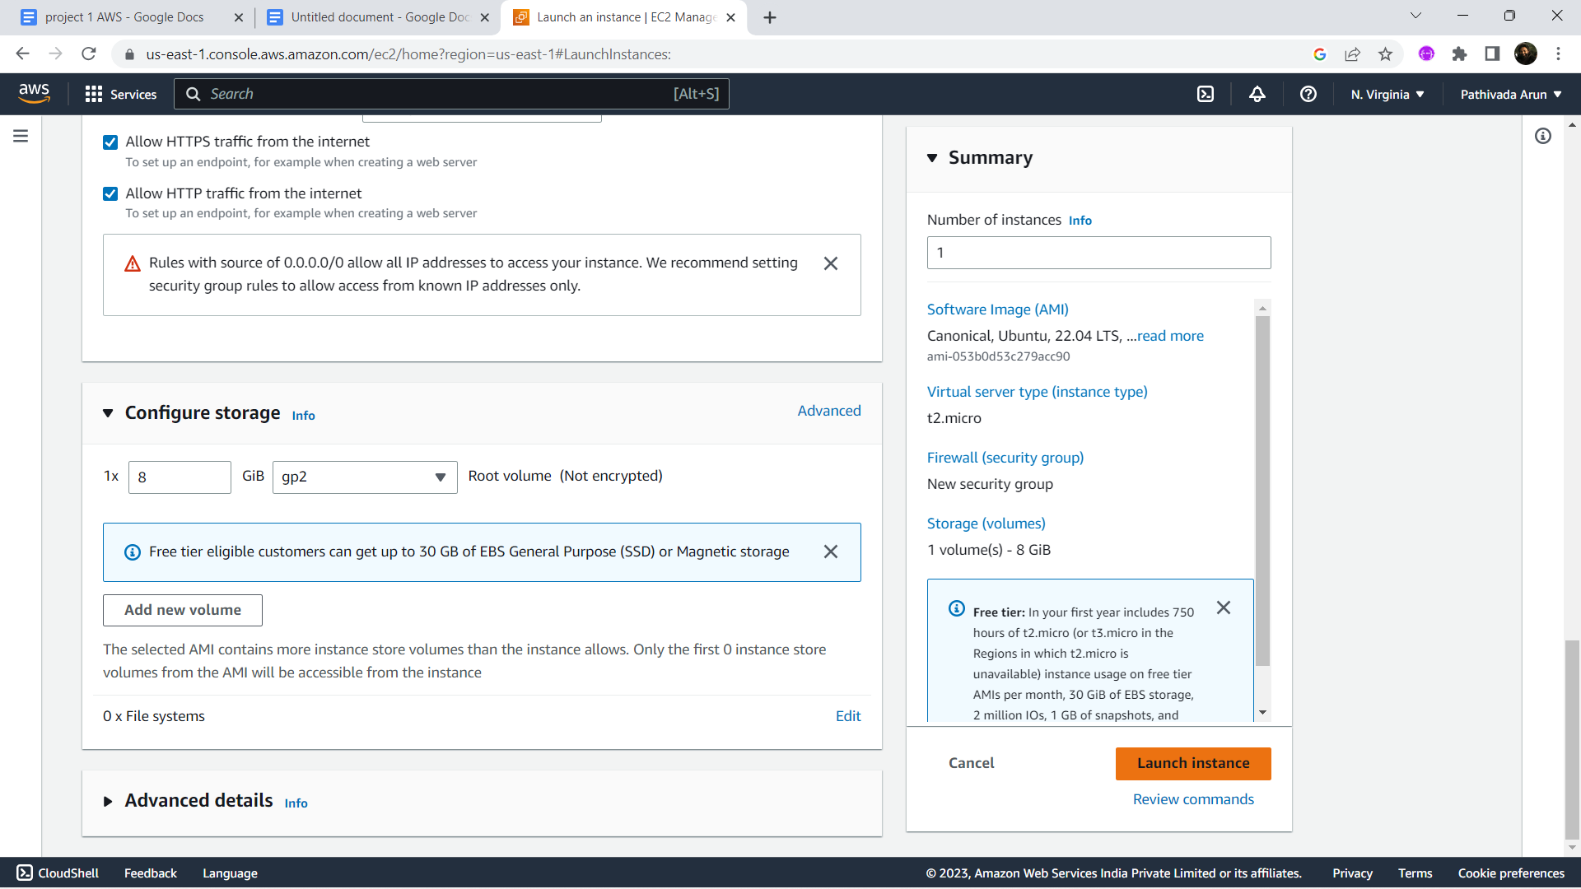

**Step 7:**

Create an elastic ip address to connect static ip address to our instance.

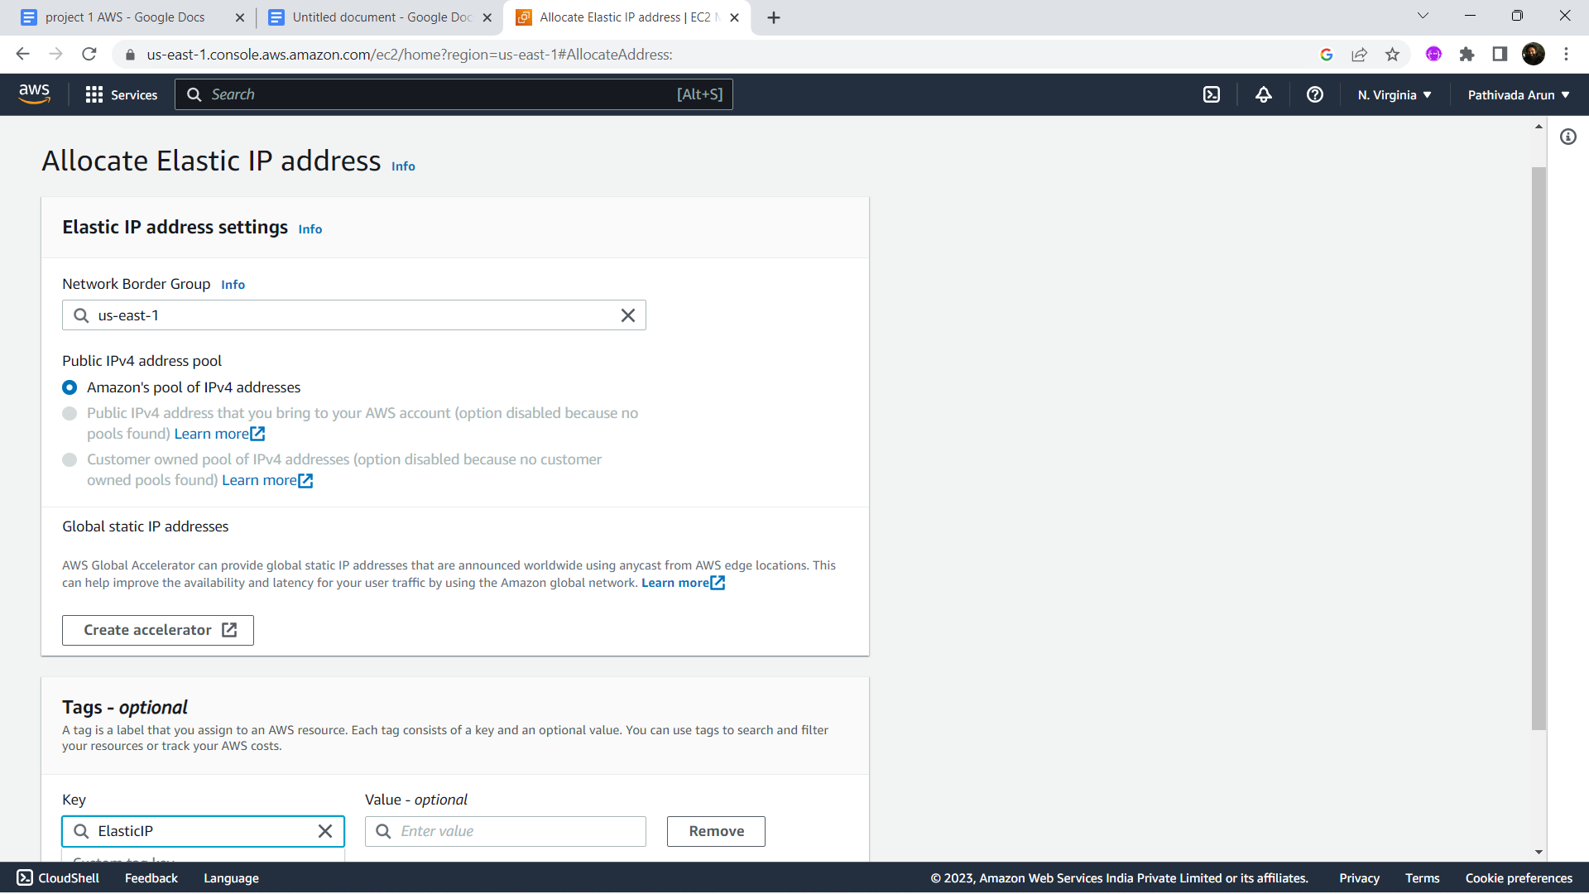

**Step 8:** Associate elastic ip address to current running instance

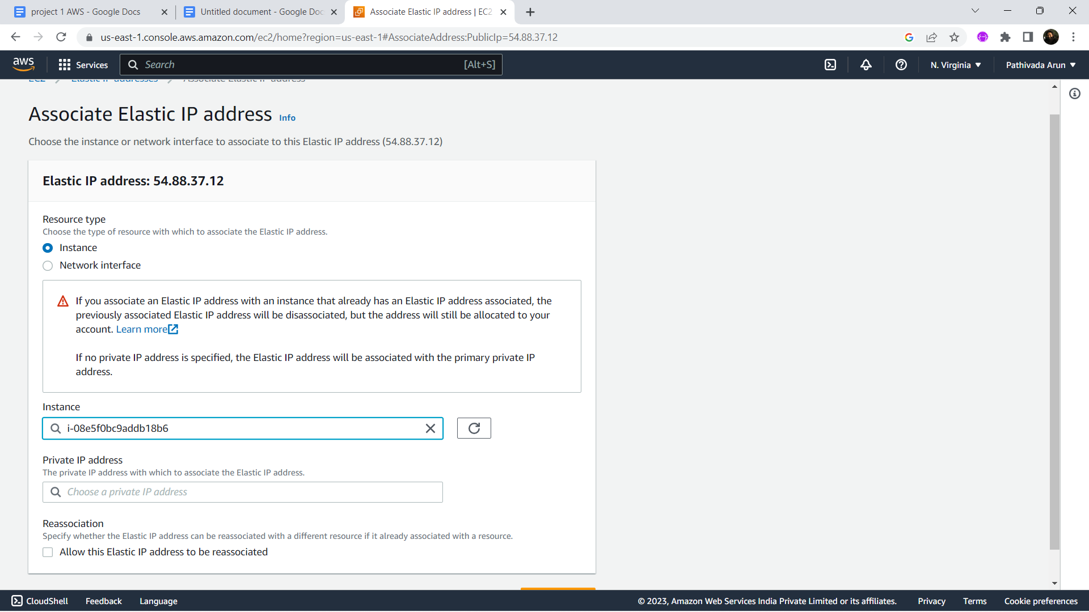

**Step 9:Git window to connect the instance**

Connect to the instance through the git bash using commands.

Firstly make sure to change directory to the pem file folder location.

Connect to the instance using the command  **ssh -i "arun2.pem"** [**root@ec2-3-86-29-169.compute-1.amazonaws.com**](mailto:root@ec2-3-86-29-169.compute-1.amazonaws.com).

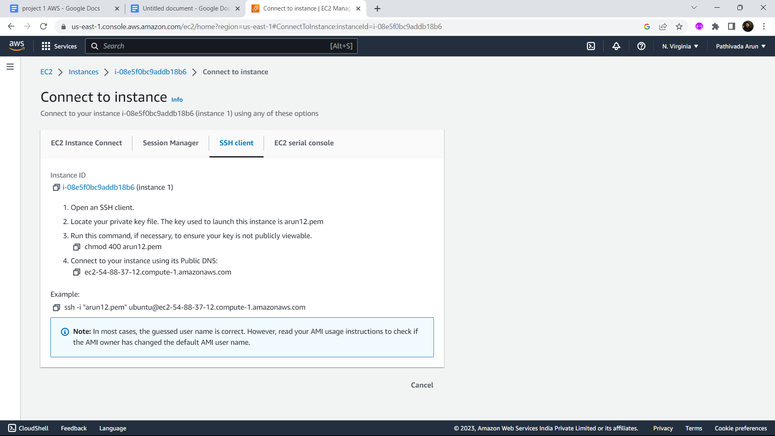

**Step 10: Install Apache server on Ubuntu**

This command installs the Apache HTTP server, which is a widely used web server software, on your Ubuntu machine. Apache will be responsible for serving your WordPress website to visitors.

**Command**: sudo apt install apache2

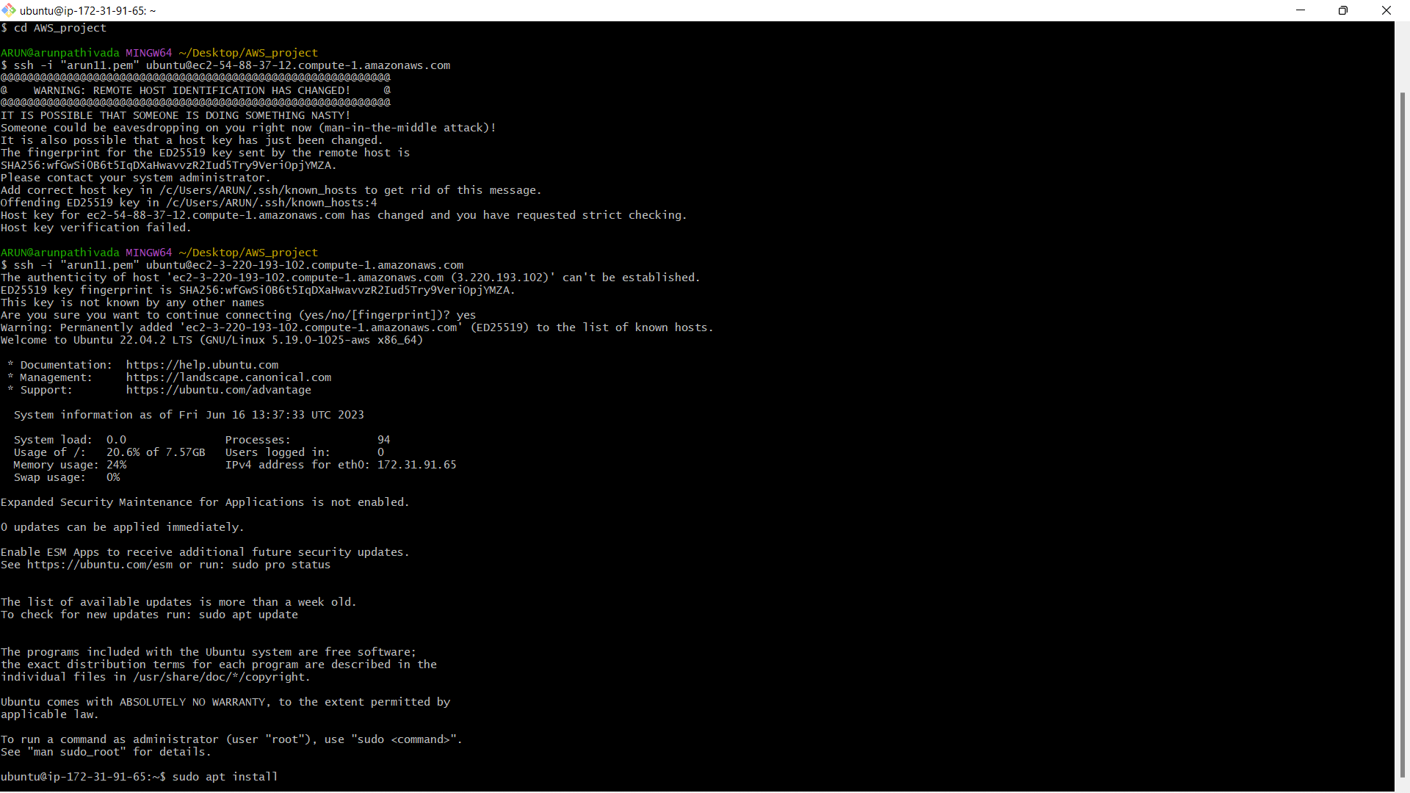

**Step 11: Install PHP runtime and PHP MySQL connector**

**Command:** sudo apt install php libapache2-mod-php php-mysql

This command installs the PHP runtime and the necessary modules to connect PHP with MySQL. PHP is a programming language commonly used for web development, and these packages enable PHP to interact with the MySQL database server.

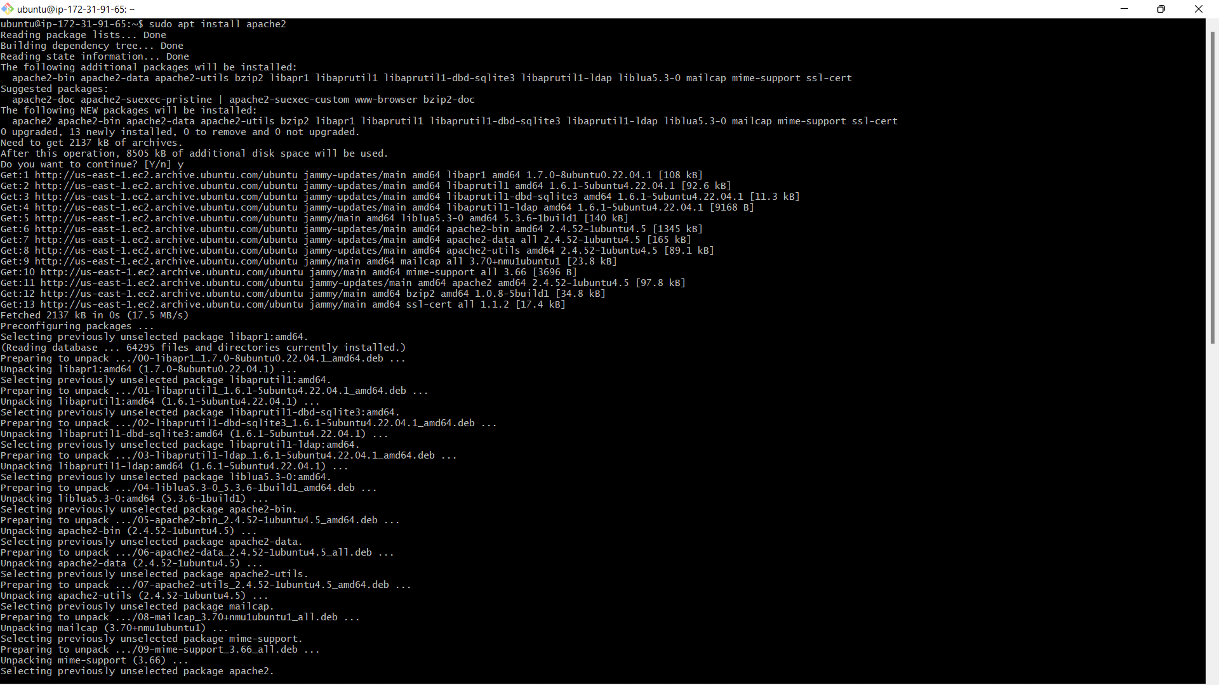

**Step 12: Install MySQL server**

**Command:**sudo apt install mysql-server

This command installs the MySQL server on your Ubuntu machine. MySQL is a popular open-source relational database management system used by WordPress to store its data.

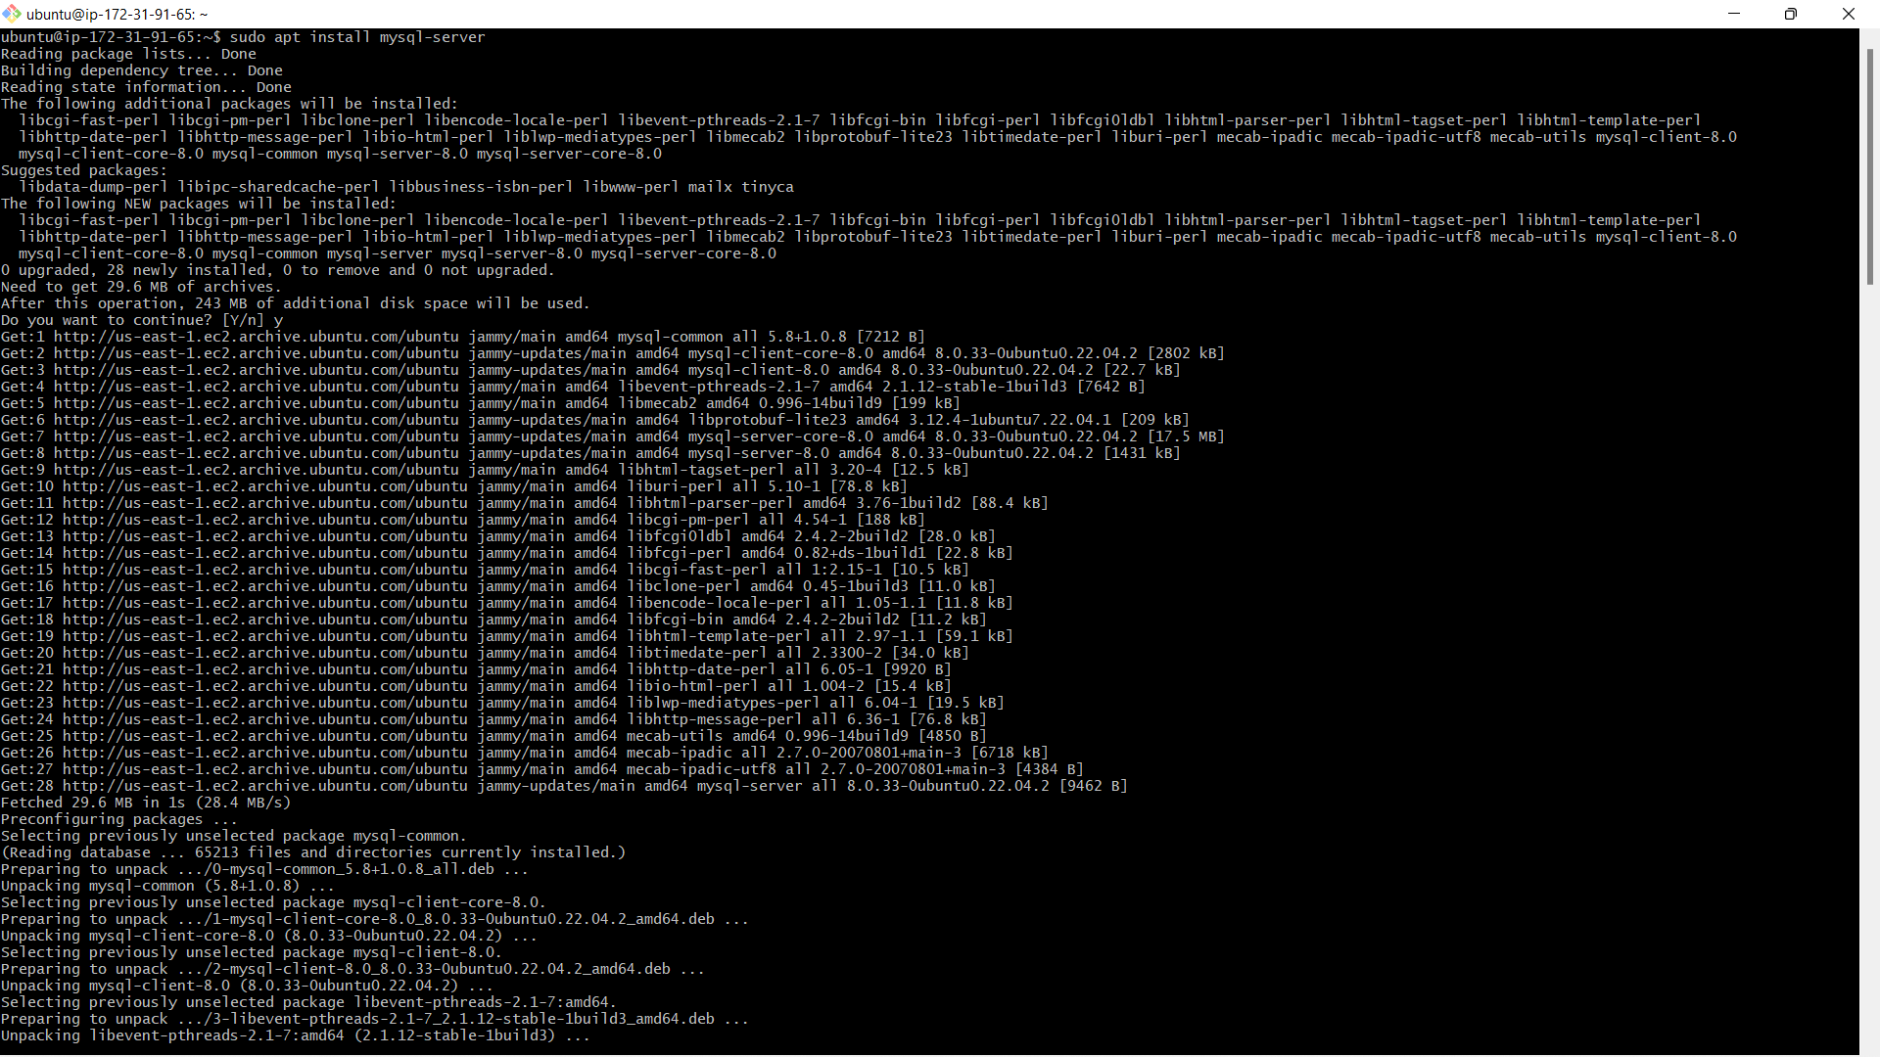

**Step 13: Login to MySQL server**

**Command:** sudo mysql -u root

This command allows you to log in to the MySQL server as the root user. The root user has administrative privileges and can perform various operations, such as creating databases and managing users.

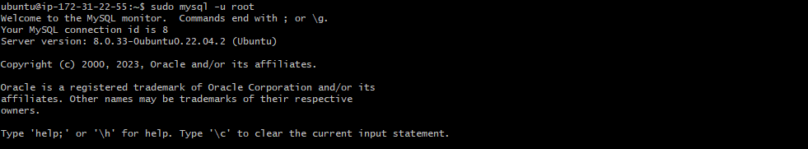

**Step 14: Change authentication plugin to mysql_native_password**

**Command:**ALTER USER 'root'@'localhost' IDENTIFIED WITH mysql_native_password by 'Testpassword@123';

This SQL statement changes the authentication plugin for the root user to ***mysql_native_password***, which is the traditional MySQL authentication method. It also sets the password for the root user to 'Testpassword@123'. This step enhances the security of your MySQL server



**Step 15: Create a new database user for WordPress**

**Command:** CREATE USER 'wp_user'@localhost IDENTIFIED BY 'Arun@143';

This SQL statement creates a new database user named 'wp_user' with the specified password ('Testpassword@123'). This user will be used by WordPress to connect to the MySQL server and access the necessary database.



**Step 16: Create a database for WordPress**

**Command:**CREATE DATABASE wp;

This SQL statement creates a new database named 'wp' specifically for your WordPress installation. WordPress will use this database to store its data, including posts, pages, comments, and other site-related information.



**Step 17: Grant all privileges on the database 'wp' to the newly created user**

**Command:**GRANT ALL PRIVILEGES ON wp.* TO 'wp_user'@localhost;

This SQL statement grants all privileges (such as SELECT, INSERT, UPDATE, DELETE) on the 'wp' database to the 'wp_user' user. This step ensures that the user has the necessary permissions to manage and manipulate the WordPress database.



**Step 18: Download WordPress**

**Command:** cd /tmp

**Command:** wget https://wordpress.org/latest.tar.gz

These commands navigate to the /tmp directory (a temporary directory) and download the latest version of WordPress as a compressed tarball. The tarball contains all the WordPress files needed for installation.

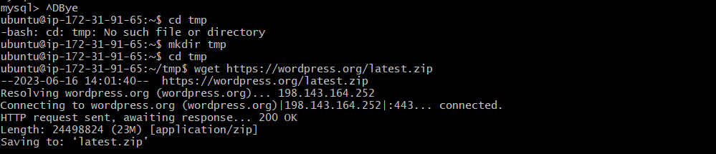

**Step 19: Unzip WordPress**

**Command:**tar -xvf latest.tar.gz

This command extracts the contents of the WordPress tarball. It unpacks all the files and directories, making them accessible for installation and configuration.

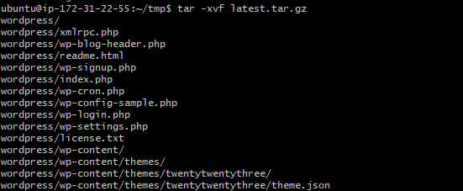

**Step 20: Move WordPress folder to Apache document root**

**Command:** sudo mv wordpress/ /var/www/html

This command moves the extracted WordPress files and directories to the Apache document root directory, which is typically located at /var/www/html. The Apache web server will serve the files from this location when visitors access your WordPress website.



**Step 21: Restart/reload Apache server**

**Command:**sudo systemctl restart apache2



**Step 22:**

change directory to the installed files location /var/www/html



**Step 23:**

Open web page to login into wordpress website

Use elastic ip address to get the login page **3.80.137.199/wordpress**

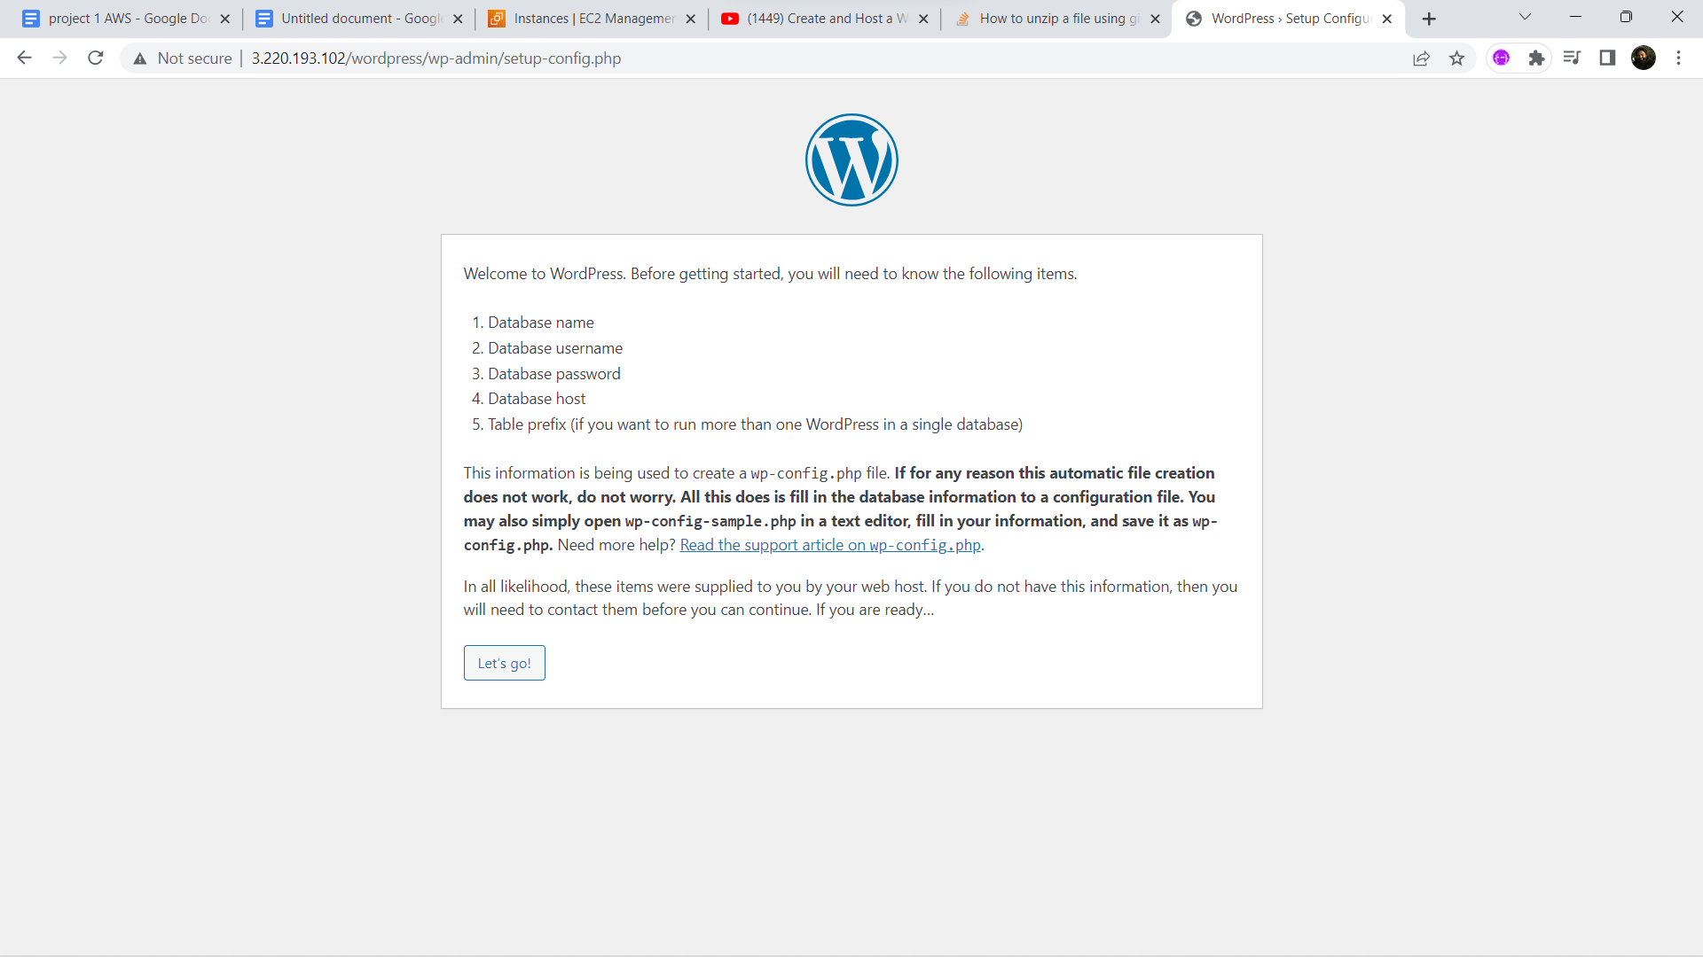

**Step 24:**It gets an error ,we need to create a file as ip_config.php and paste the below lines and save them.

**Command:** nano ip_config.php

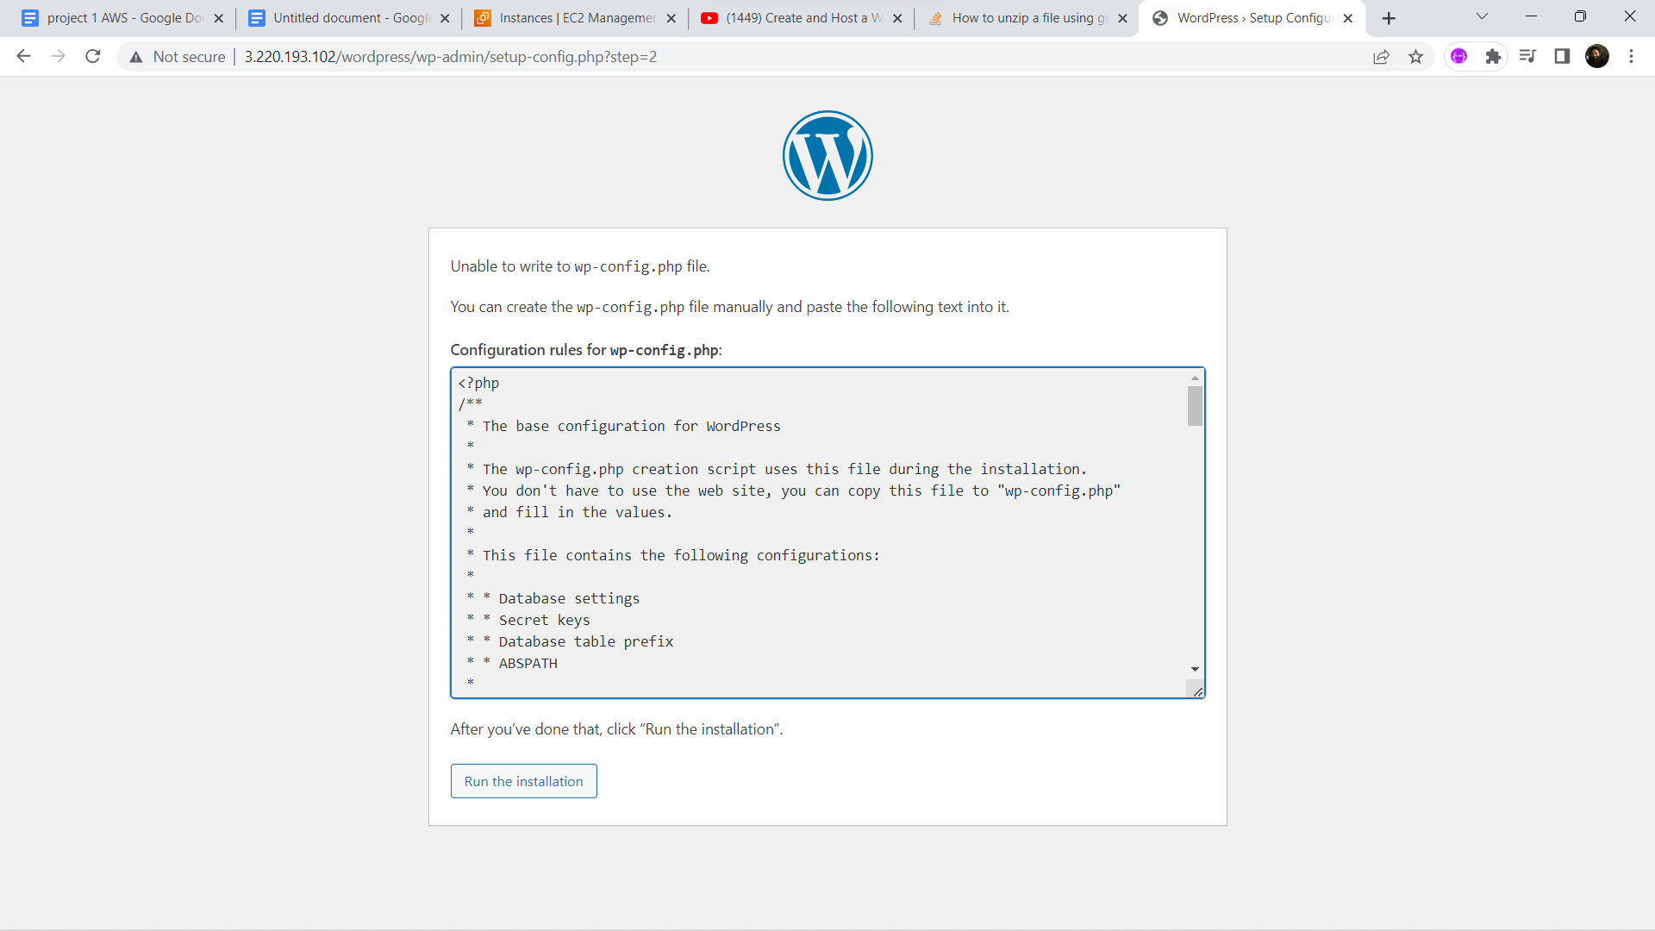

**Step25:** We need to give title ,username ,password and email address.

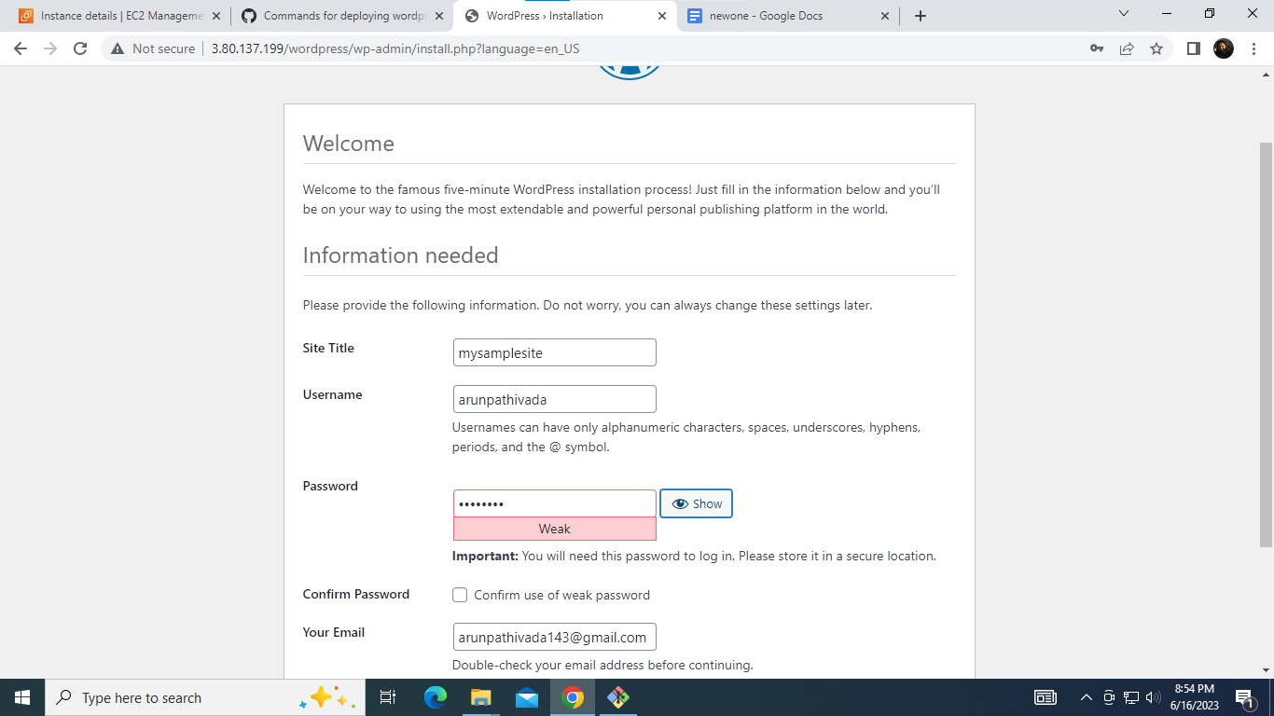

**Step 26:** We get the dashboard page of the wordpress,where we need to publish out blogs with a title

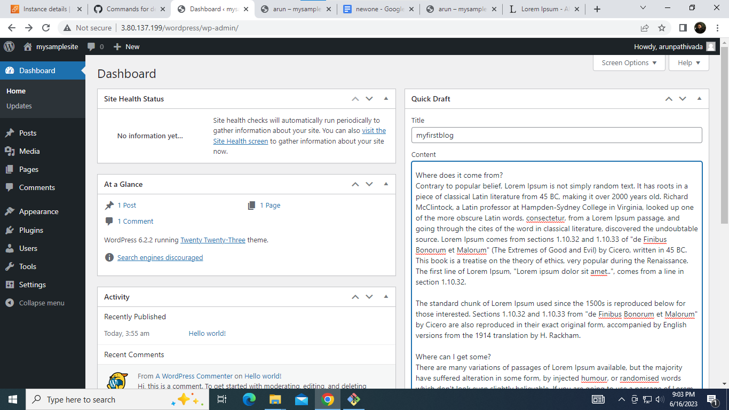

**Step 27**:Once published,copy the address and paste in browser to get the complete blog

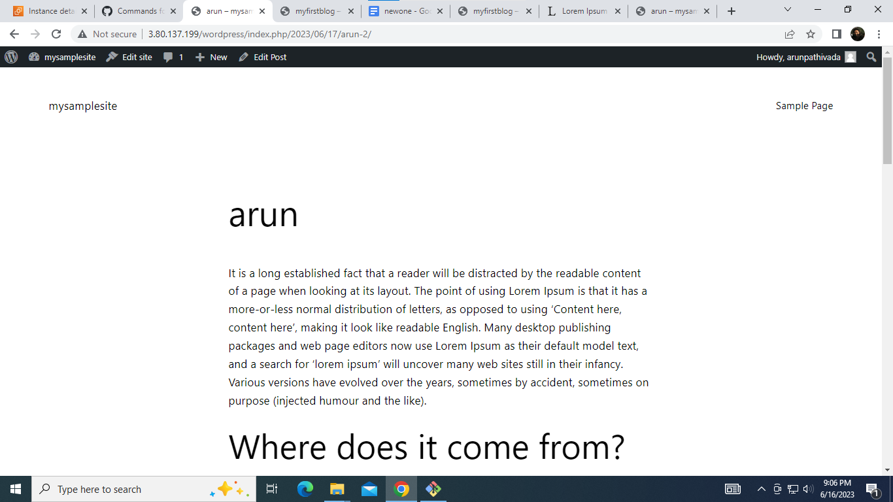

**Step 28:To check the created data in our mysql database wp**

**Command:** sudo mysql root -p

Use database by using command: use wp

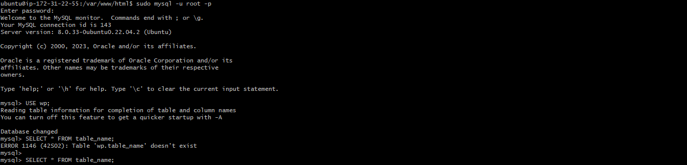

**Step 29:To see tables in database**

**Command:**show tables

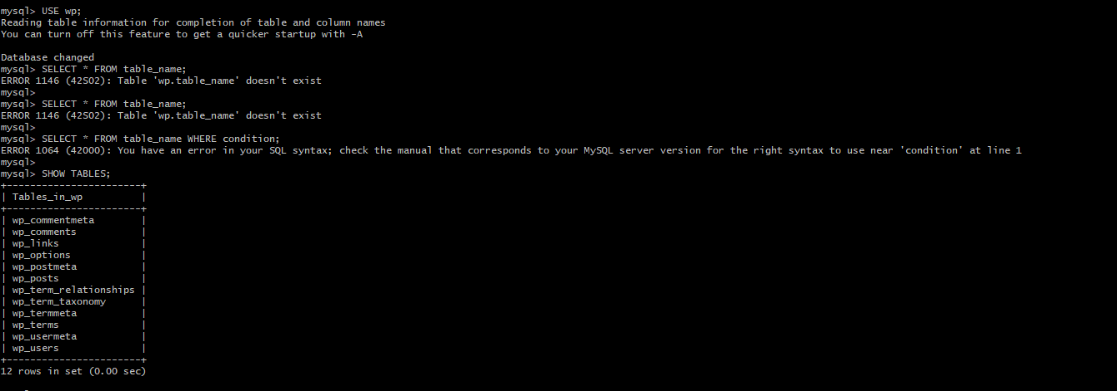

**Step 30: To see the content open wp_posts table**

**Command:** SELECT * FROM wp_posts

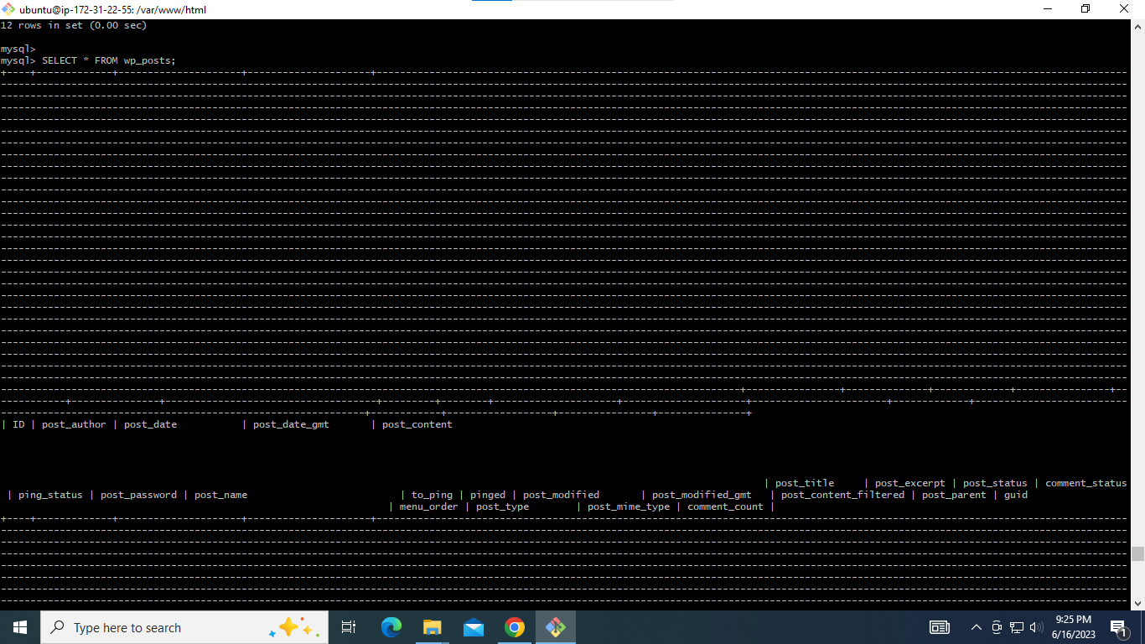

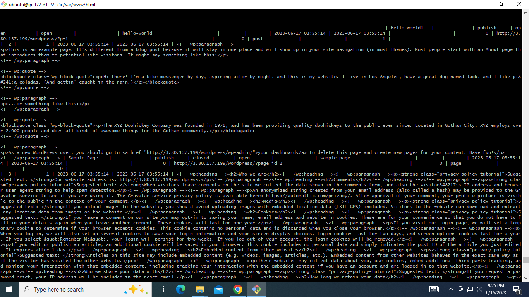

**END**